**Executive Summary:**

**Introduction**

Since the video game industry's inception in the late 1970s, a lot has changed. Millions of players worldwide have been enthralled with its highly realistic virtual worlds, which have progressed beyond basic pixelated graphics. With two primary objectives, this study attempts to thoroughly examine the best 400 video games released between 1977 and the present:

1. Finding the Best Years in Gaming: We want to explore the years when video games truly shone, when they impressed both players and industry experts.

2. Understanding the Business Side of Gaming: By closely examining sales data, we'll uncover the financial aspects that have influenced the gaming industry, revealing trends, patterns, and significant milestones.

**Project Scope**

Our analysis will focus intently on the top 400 video games, covering various genres and platforms. This focus allows us to understand how the gaming industry has evolved and how user and critic preferences have changed over time. By studying these top 400 games, we can recognize the most influential creations in the industry and track the trends that have shaped the gaming world.

Evaluating User and Critic Satisfaction

To assess user and critic satisfaction, we're taking a two-pronged approach. Firstly, we'll examine user reviews, using a large dataset of player feedback to understand what makes a game appealing. Secondly, we'll dive into professional critic reviews, looking at their assessments of game mechanics, storytelling, visuals, and overall impact. Combining these perspectives will give us a comprehensive view of what makes a video game truly outstanding.

Exploring the Economics of Gaming

The financial aspect of the gaming industry is intricate and always changing. We will carefully study sales data, looking at revenue figures, market share trends, and the influence of technology improvements in order to manage this challenging environment. With the aid of this thorough study, we will be able to pinpoint the economic variables that have shaped the sector and uncover patterns and trends that have aided in its expansion and development.

**Expected Outcomes**

Through our comprehensive analysis of the top 400 video games, we expect to achieve several significant results:

1. Spotting the Golden Years of Gaming: We aim to identify the years when video games reached their peak, captivating both players and critics with groundbreaking innovations and captivating experiences.

2.Revealing Economic Trends and Patterns: Our examination of sales data will uncover the financial factors that have driven the growth and evolution of the gaming industry, revealing trends and patterns that have influenced its trajectory.

3. Knowing Player and Critic Preferences: We aim to identify the critical elements that lead to a game's success by examining user reviews and expert critic evaluations. This will provide us an understanding of the preferences of both players and industry professionals.

4. Developing a Useful Resource for Industry experts: This project's findings should be a useful tool for scholars, industry experts, and enthusiasts, providing them with information about the history and current state of the gaming industry's economy.

Problem Statement:

Since the video game business first emerged, it has seen a significant transformation. The game experience has evolved dramatically from basic pixelated games to rich virtual worlds. But these advancements have also brought about important problems that require attention:

1. Understanding Gamer Preferences: Understanding what makes gamers and critics tick is crucial for the success of video games. To make fun and interesting games, it's crucial to understand how these elements have changed and developed over the years.

2. Analyzing Gaming Economics: A multitude of factors, such as sales, market trends, and technological advancements, have an impact on the multibillion-dollar gaming industry.

3. Analyzing Data: This project involves analyzing a vast amount of data, encompassing 400 games across diverse genres and platforms, spanning numerous years. This data includes user reviews, critic ratings, sales figures, and historical context. Effectively managing and extracting meaningful insights from this data is a significant challenge.

The project aims to share its findings in a way that benefits researchers, industry professionals, and gaming enthusiasts alike. The challenge lies in presenting the complex evolution of the gaming industry and its economic landscape in a clear and actionable manner.

In summary, the key challenges involve understanding gamer preferences, deciphering the economic drivers of the industry, managing a vast amount of data, and effectively communicating findings to a wide audience.

**LITERATURE REVIEW**

Given the breadth and diversity of the field of video game history, a literature study on the evolution of video games can cover a wide range of subjects and themes.

**Early Video Game History:**

Video games have their roots in early computer graphics and interactive technology projects from the 1950s and 1960s. Trailblazing video games such as "Spacewar!" and "Tennis for Two" established the industry's framework.

**Arcade Games during the Golden Age:**

Classics like "Pac-Man," "Space Invaders," and "Donkey Kong" became cultural icons during the late 1970s and early 1980s arcade gaming boom. This time frame is frequently called the "Golden Age " of video games

**Home Consoles and the Crash of 1983:**

The debut of home video game consoles, such as the Atari 2600, and the ensuing 1983 video game market slump temporarily brought the industry to its knees.

**Nintendo and the Revival:**

Nintendo's contribution to the video game industry's revival with the advent of the Nintendo Entertainment System (NES) and well-known franchises like "Super Mario" and "The Legend of Zelda."

**The Shift to 3D Video Games:**

The transition from 2D to 3D gaming in the 1990s with the release of systems such as the Nintendo 64 and the Sony PlayStation. the effects of three-dimensional graphics on narrative and gameplay.

**The emergence of virtual gaming:**

The expansion of online multiplayer gaming and how it affects social relationships, financial structures, and game creation. renowned online gaming titles and services, such as Xbox Live and "World of Warcraft"

**Casual and mobile gaming:**

The advent of smartphones and app stores, which led to the growth in popularity of mobile gaming and the success of titles like "Angry Birds" and "Candy Crush Saga."

**Independent Games and Online Gaming:**

The contribution of independent game creators and online retailers such as Steam and Itch.io to the industry's diversification.

The impact of crowdsourcing and sites like Kickstarter on indie game development.

**Augmented reality and virtual reality:**

The growing popularity of augmented reality (AR) and virtual reality (VR) games on devices like Pokémon GO and Oculus Rift.

**Critical Games and Gamification:**

the use of serious games and gamification to bring gaming elements into non-gaming situations including business, healthcare, and education.

**Gaming competition and esports:**

the expansion of esports as a major worldwide phenomenon featuring professional players, competitive events, and sizable viewership.

the growth of League of Legends Championship Series and Overwatch League, two esports leagues and organizations.

**Impact on Culture and Society:**

The impact of video games on art, music, and narrative is one aspect of their cultural influence.

talks concerning how race, gender, and other social issues are portrayed in video games.

**Future Technological Trends:**

Thoughts regarding the development of virtual reality, artificial intelligence, and visuals in video games.

**Data Collection and Preparation:**

**Data Collection:**

Kaggle, a renowned website for sharing and accessing datasets, provided me with the dataset for my research. This dataset, titled "The Golden Age of Video Games | SQL Project | EDA," is rich in video game information. It includes information about game titles, genres, platforms, sales numbers, player demographics, and review ratings. After downloading the dataset from Kaggle, I discovered that it was in a useable format, basically a structured file, such as a CSV or Excel spreadsheet. This first structure made it easy to integrate into my SQL project.

Data Source : -<https://www.kaggle.com/code/ahmedabdallah1/the-golden-age-of-video-games-sql-project-eda/input>

**Data preparation:**

In the process of preparing the dataset, I first performed data cleaning to ensure its quality and accuracy. This involved addressing issues like missing values, correcting data types, and identifying and dealing with any outliers or anomalies.

During my data cleaning process in Jupyter Notebook, I focused on enhancing the dataset's quality and completeness, particularly in the "reviews" field; none of the other tables had missing values. The columns "game," "user_score," and "critic_score" in this table held critical information. I fixed missing values in the "user_score" and "critic_score" columns to ensure the dataset was ready for analysis. Missing data might jeopardize the validity of analytical results; therefore I used imputation techniques to fill in the gaps. I attempted to improve the dataset's usability for further studies by imputing missing values in the "user_score" and "critic_score" columns, ensuring that no crucial information was neglected or removed. In my study, this data cleansing phase was critical for getting robust and dependable findings.

To ensure a clear understanding of the dataset, I created a data dictionary or metadata, documenting the meaning of each column and units of measurement. Finally, I formatted and exported the cleaned and prepared dataset in a manner compatible with my SQL project, including any schema design to represent the data effectively. This meticulous data collection and preparation process laid the foundation for meaningful exploratory data analysis and SQL-based insights into the golden age of video games.

I ran a comprehensive check on the tables to ensure there are no missing values.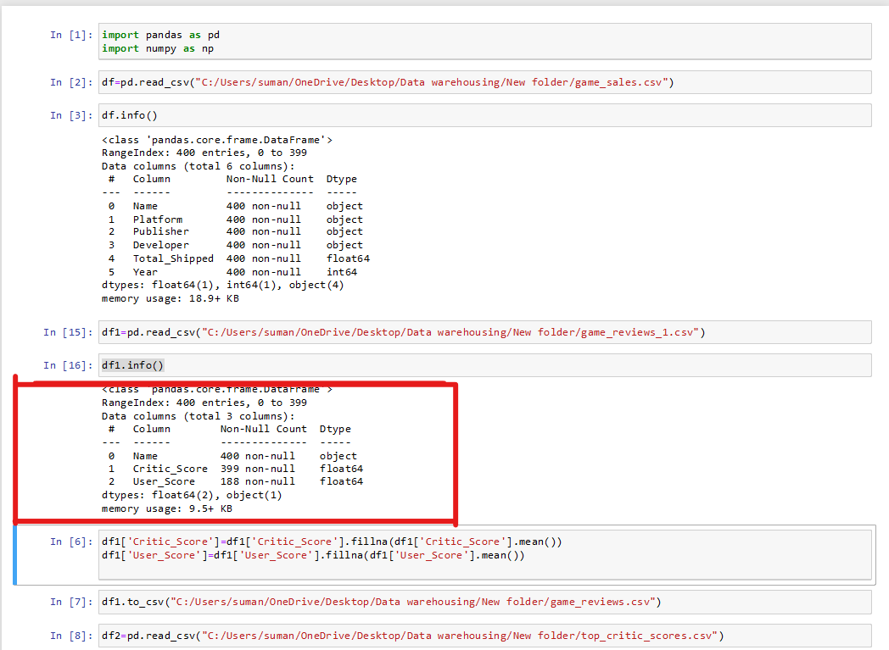

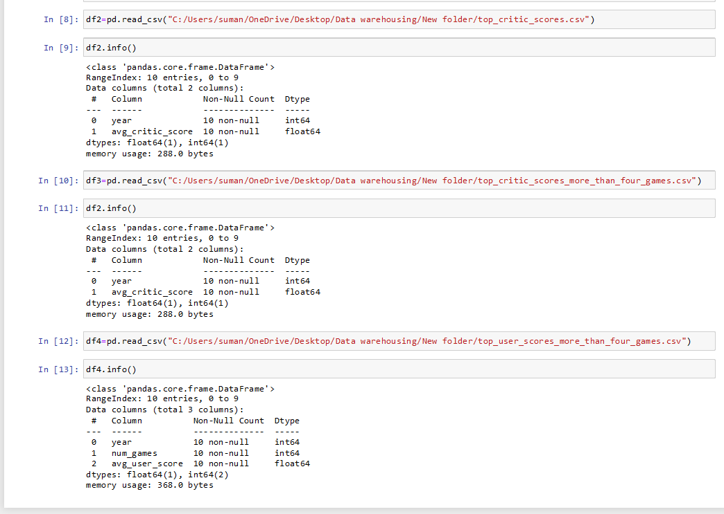

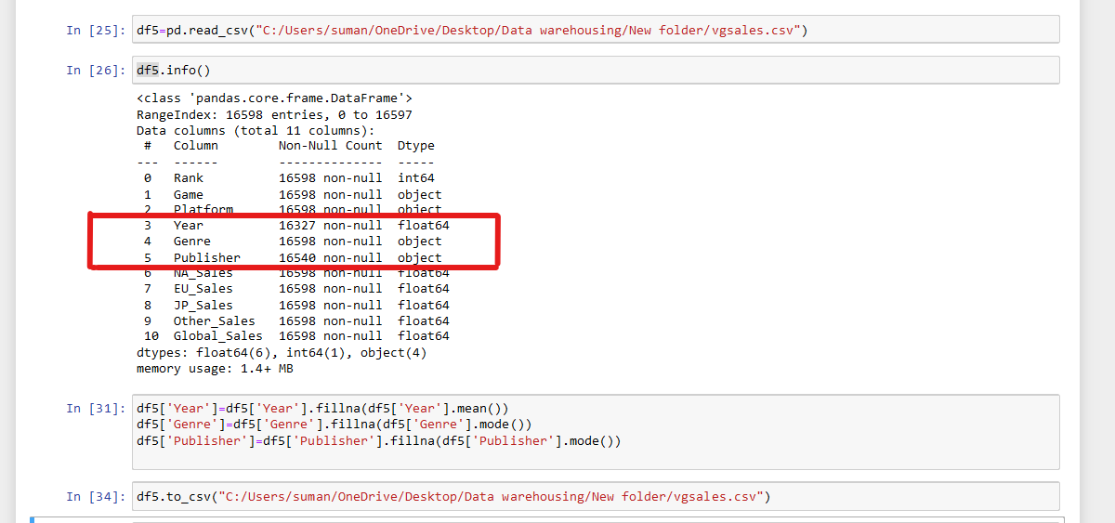

**Data Dictionary:**

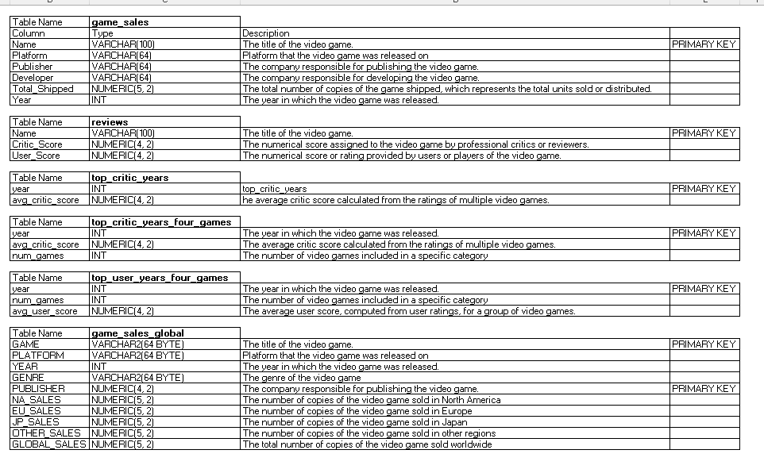

**5.Database Design:**

**ERD Diagram**

The Entity-Relationship Diagram (ERD) was a critical stage in my data warehousing project, which began with a dataset collected from Kaggle and offered insights on the Golden Age of Video Games. I converted this rich dataset into a structured database using painstaking design and execution within Oracle SQL Developer. The ERD serves as the architectural plan for the database, displaying the relationships between the many tables built for this project. These tables, which include "game_sales," "game_reviews," "top_critic_score," "top_critic_scores_more_than_four_games," and "top_user_scores_more_than_four_games," serve as the foundation of my data warehouse project. The ERD acts as a guiding framework, encapsulating not only the links between these tables but also highlighting the main entities, traits, and connections required for complete data analysis.

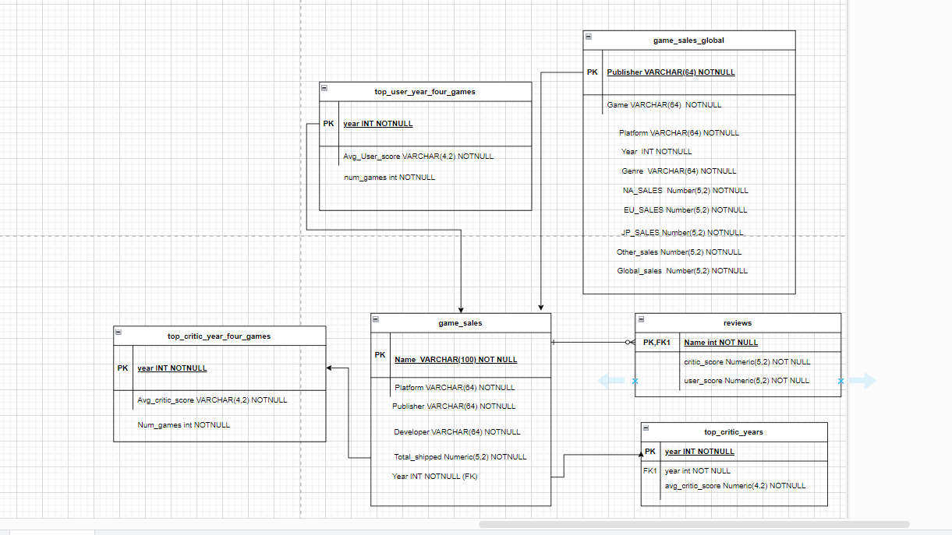

**Creating table**

In order to gain significant insights from a Kaggle dataset, I began on a complete database design journey. The Golden Age of Video Games dataset offered a treasure mine of information on game sales, reviews, and critical ratings. My database design approach started with the development of an organized schema for effective data storage and retrieval. Using Oracle SQL Developer, I painstakingly created tables to house this abundance of data, laying the groundwork for my data analysis adventure.

I defined and built five critical tables in my Oracle SQL Developer environment: "game_sales," "game_reviews," "top_critic_score," "top_critic_scores_more_than_four_games," and "top_user_scores_more_than_four_games." These tables were carefully designed to capture various characteristics of the dataset. "game_sales" stores information on game sales, whereas "game_reviews" stores user reviews and ratings. "top_critic_score" highlights games with high critical scores, while "top_critic_scores_more_than_four_games" and "top_user_scores_more_than_four_games" tables highlight games with high critical and user scores over many titles, respectively.

**Table Name – game_sales**

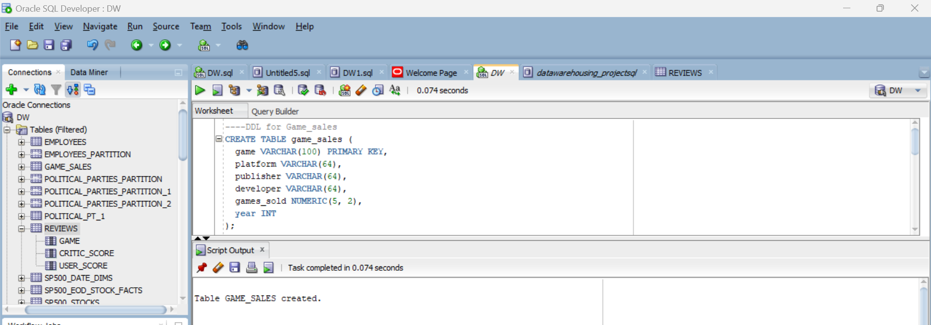

**Table Name – reviews**



**Table Name – top_critic_years**



**Table Name – top_critic_years_four_games**

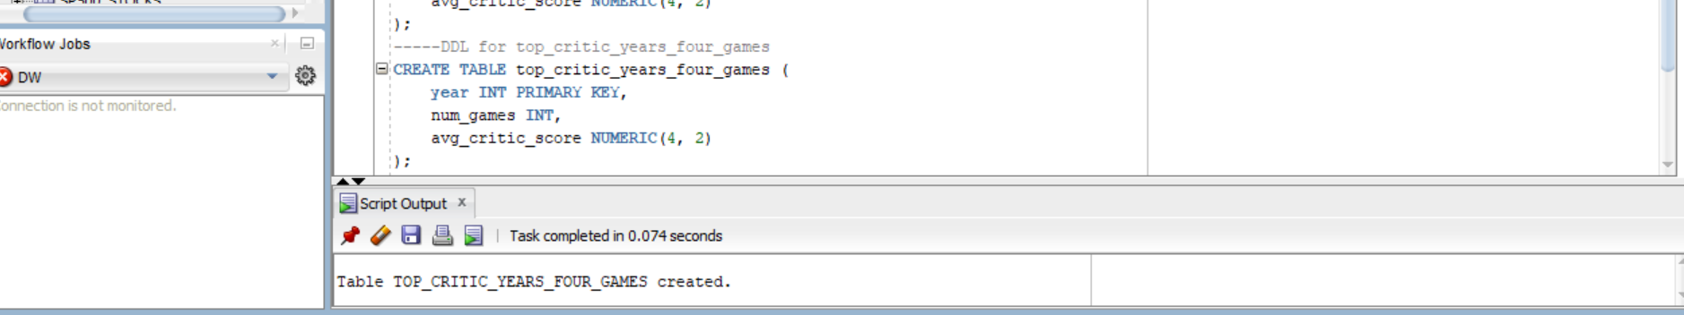

**Table Name – top_user_years_four_games**

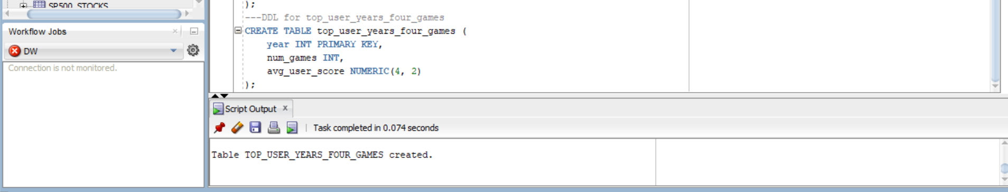

**Table Name – game_sales_global**

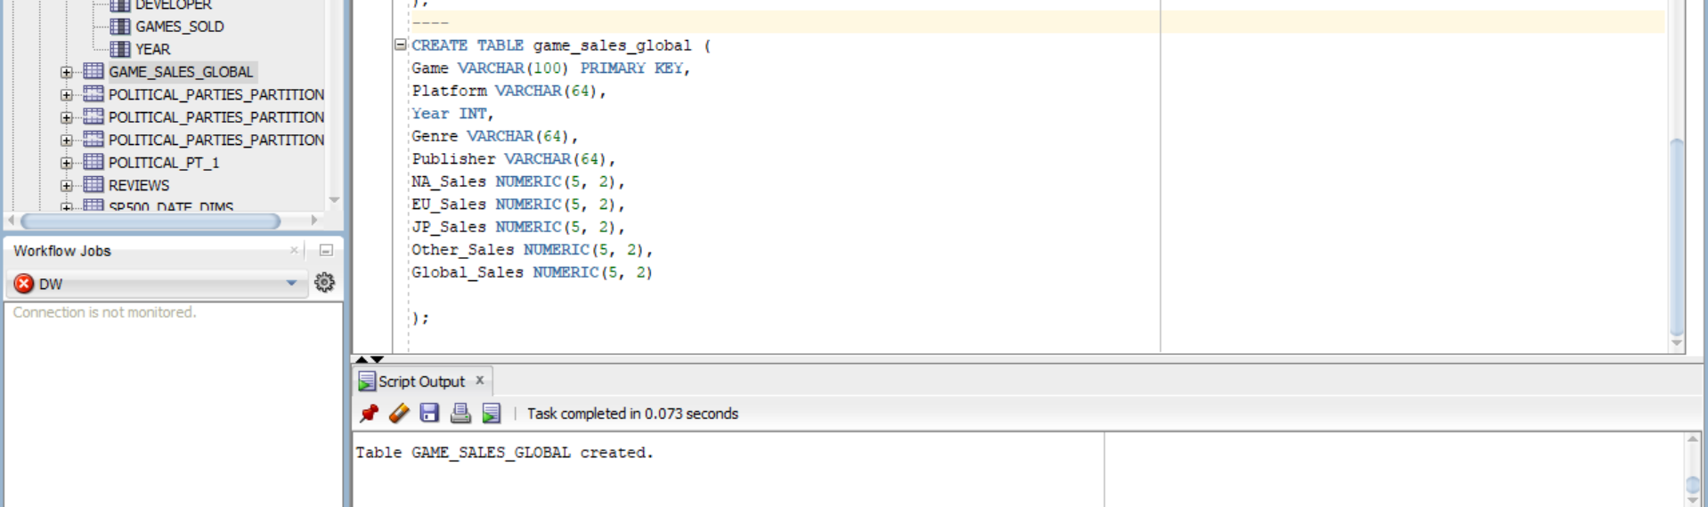

**Importing the Data:**

Importing data into these tables brought the dataset to life within my database. Each table was populated with pertinent data from the Golden Age of Video Games dataset, allowing for seamless data analysis and insights. By generating and filling these tables with data, I created the framework for executing complex SQL queries, data cubes, and exploratory data analysis to gather vital information about this critical period in video game history. My database architecture serves not only as an organized archive for this one-of-a-kind dataset, but also as a powerful tool for uncovering the tales and trends of the Golden Age of Video Games.

**Snapshot of game_sales data:**

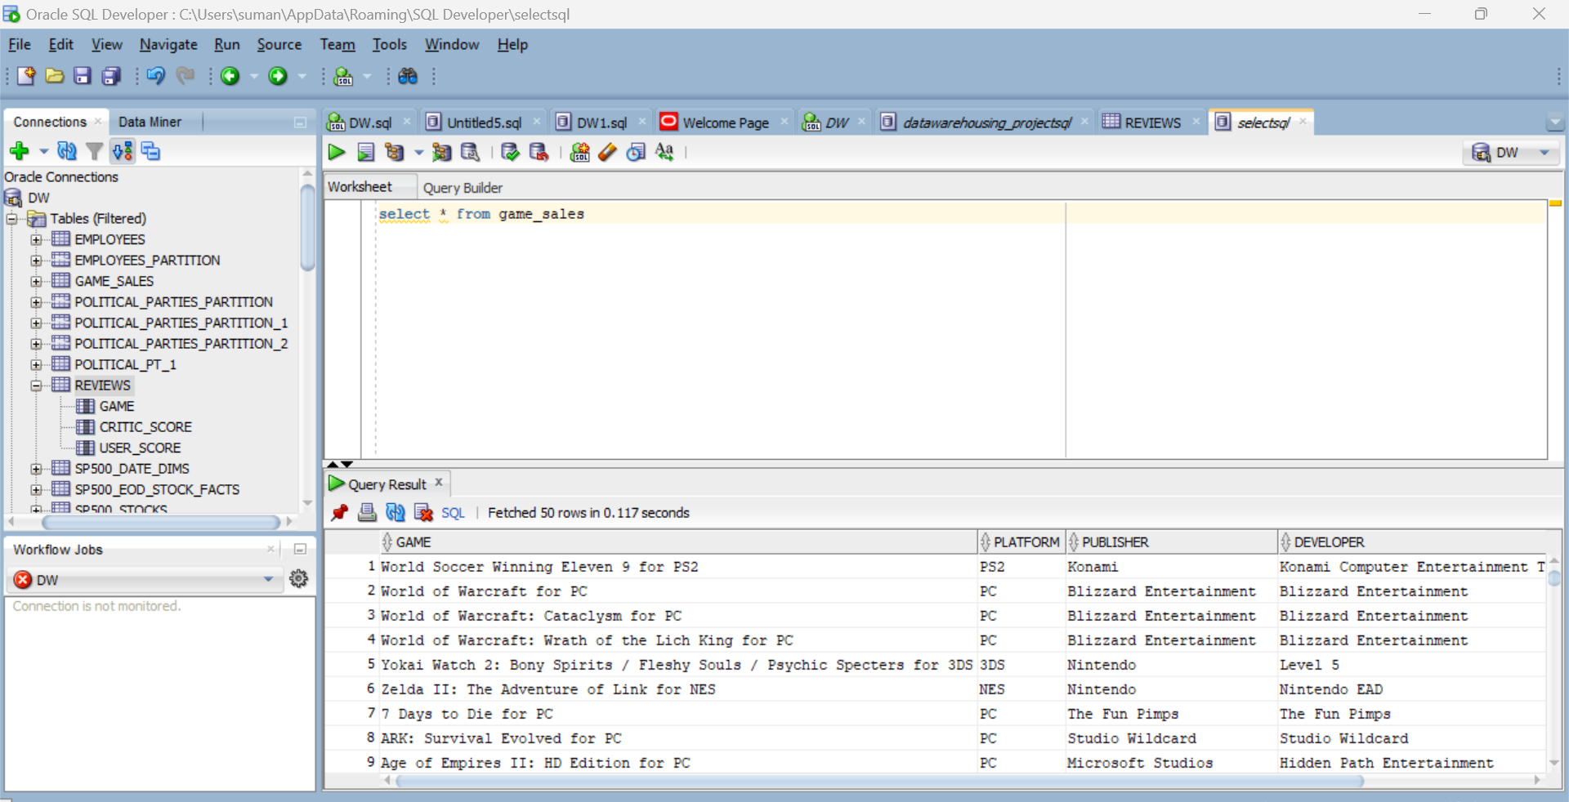

**Snapshot of reviews data:**

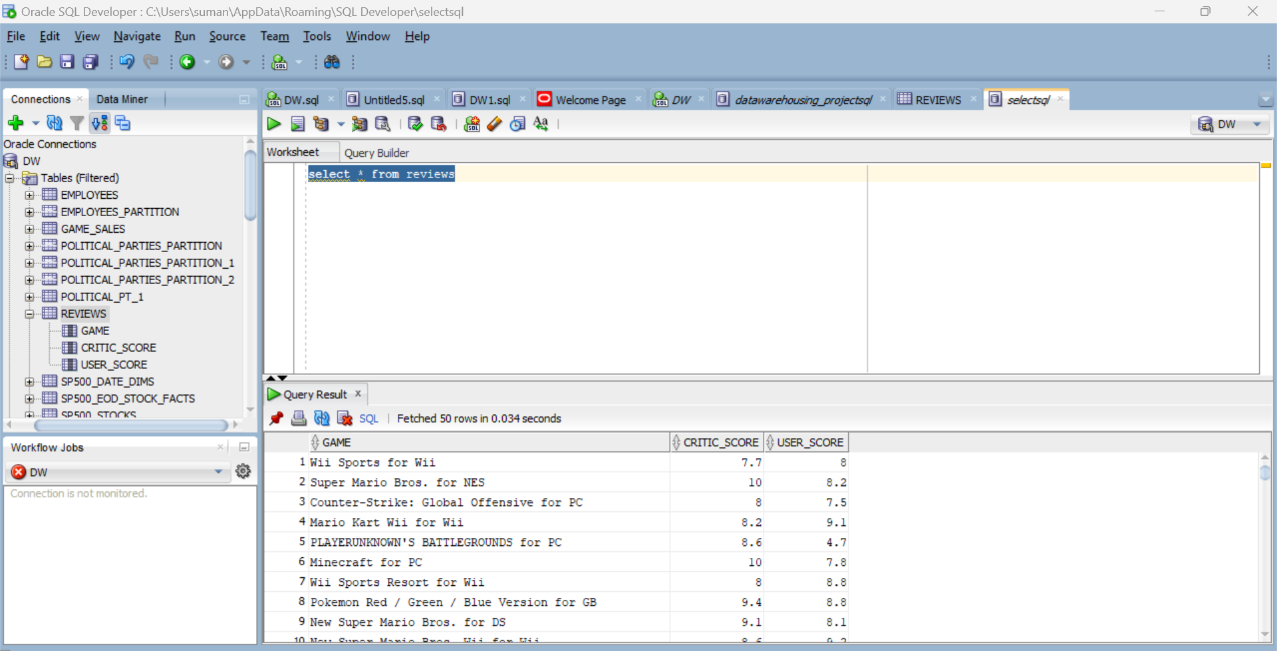

**Snapshot of top_critic_years data:**

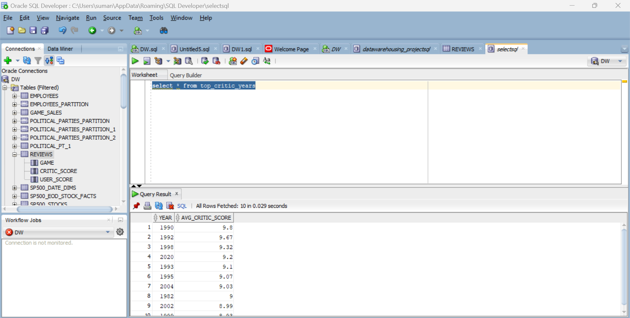

**Snapshot of top_critic_years_four_games data:**

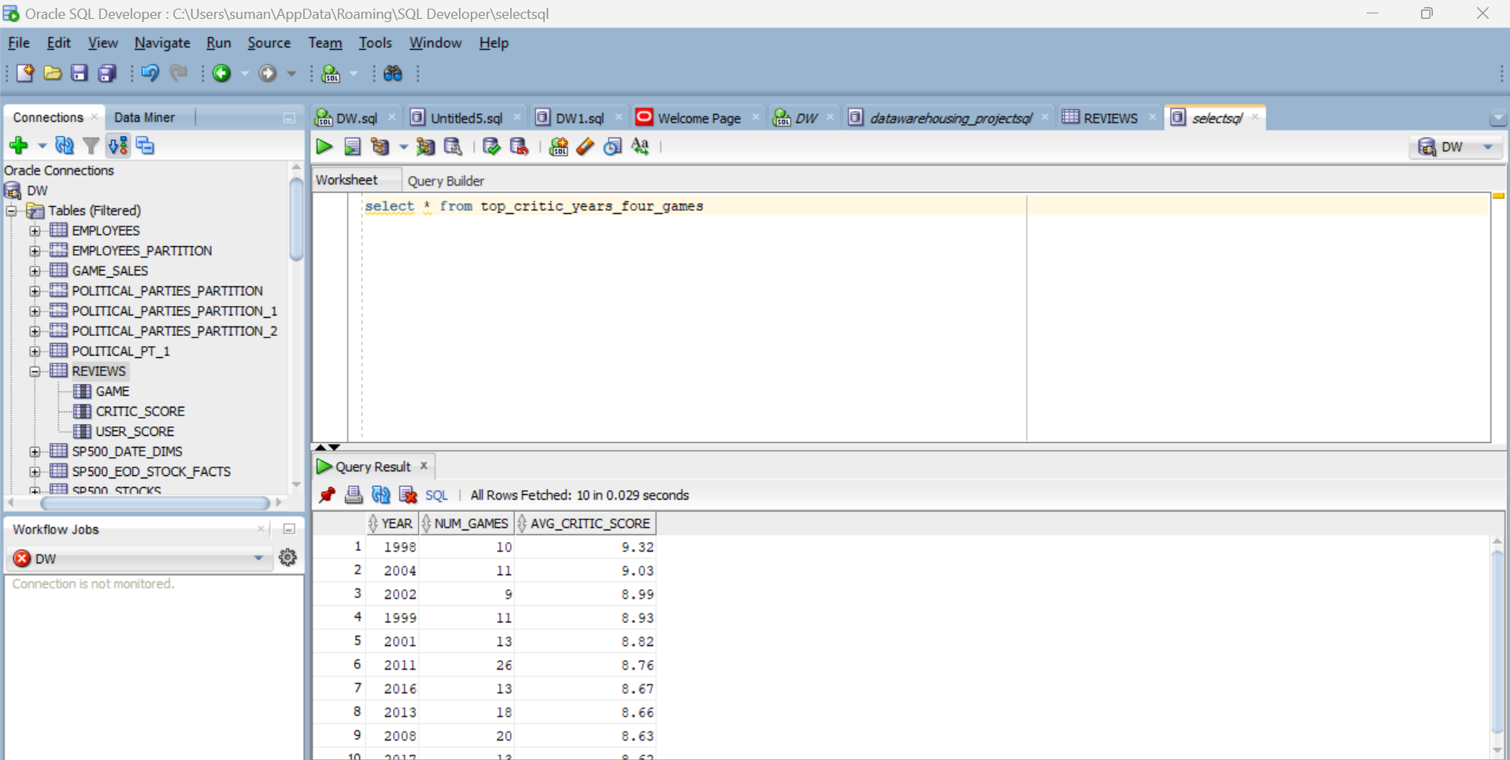

**Snapshot of top_user_years_four_games data:**

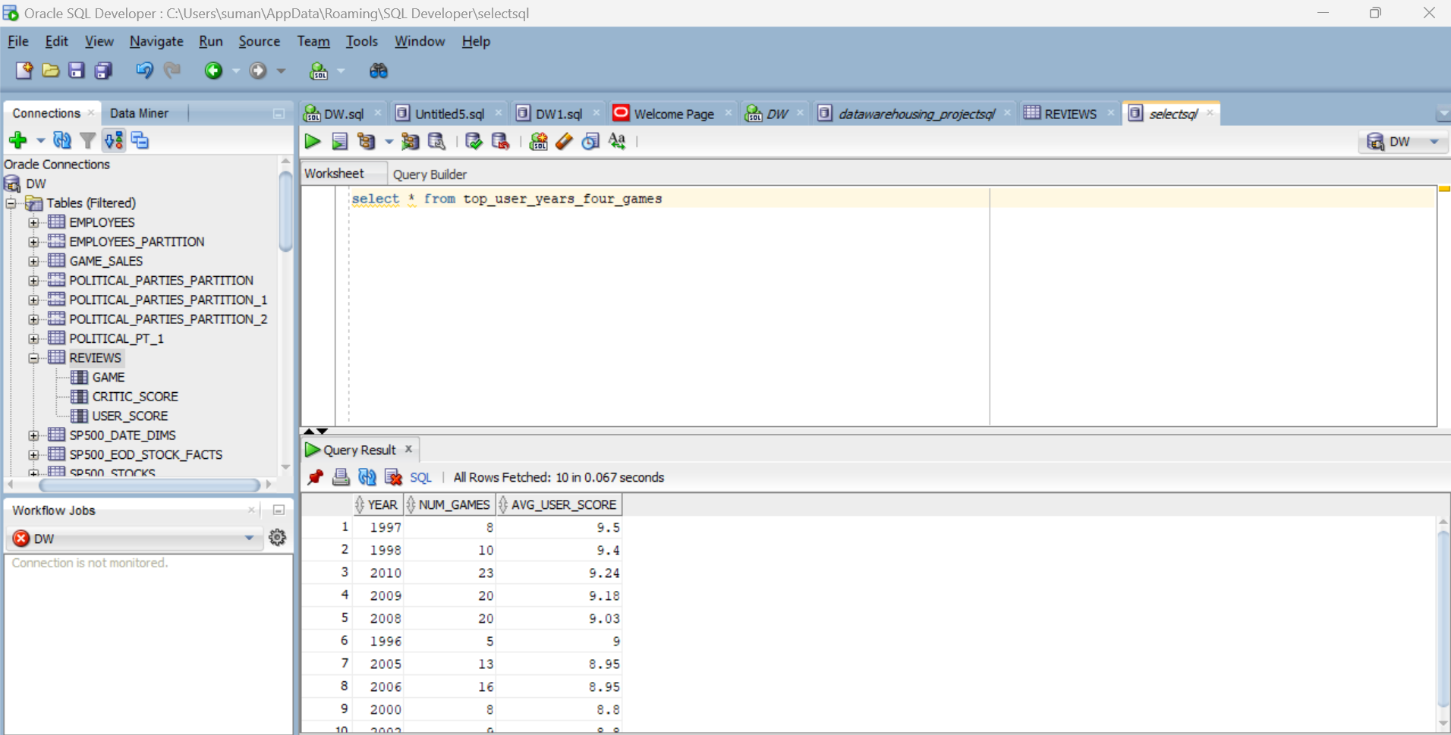

**Snapshot ofgame_sales_global**

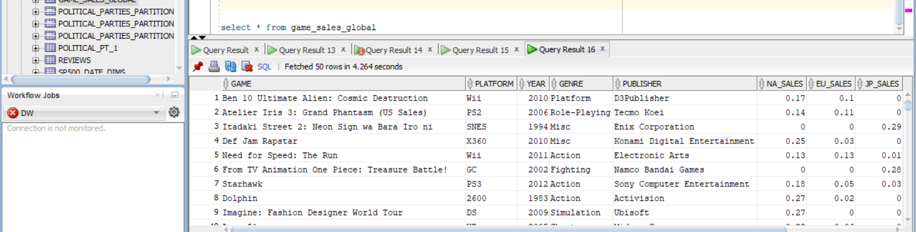

**Data Cubes:**

In data warehousing and business intelligence, data cubes are an essential component of multidimensional data modeling. In your project titled "The Golden Age of Video Games," you created data cubes to aid in multidimensional analysis.

**1. Game Sales Data Cube Query:**

This query returns total game sales grouped out by platform, developer, and year. It enables you to find the best-selling games in various combinations of these parameters.

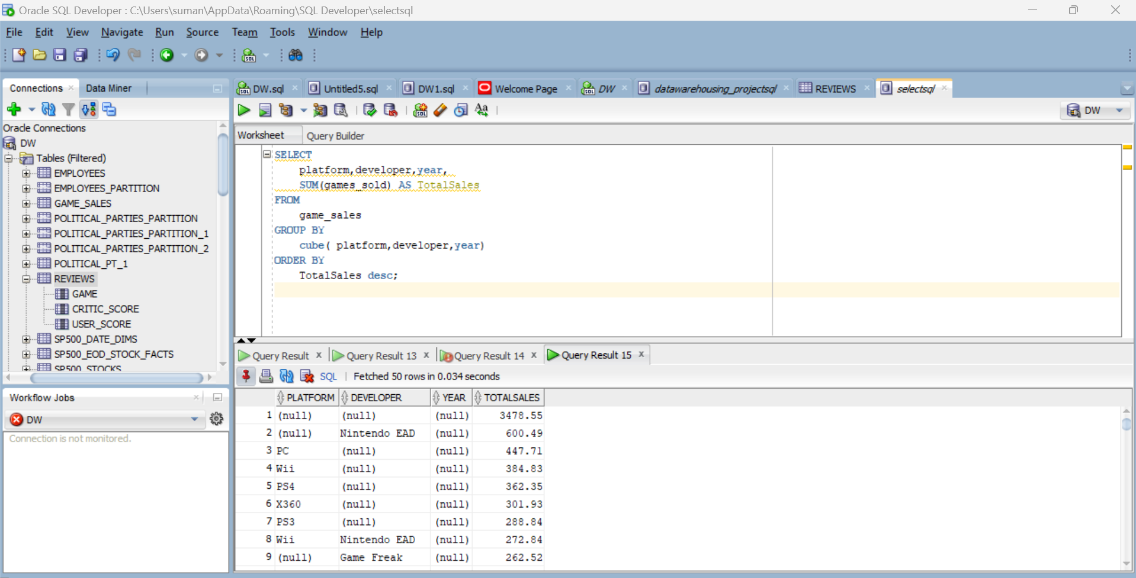

**2.Game Review Ratings Data Cube Query:**

This query computes the average critic and user scores for games. It aids in the identification of games with the highest average rating from both reviewers and users.

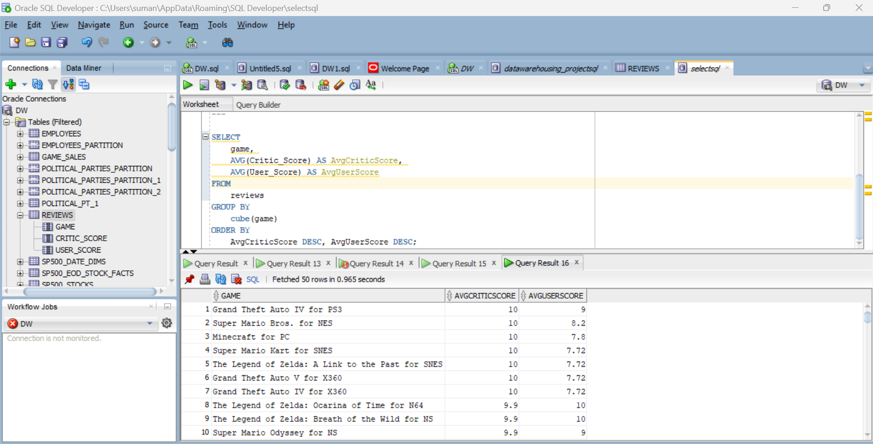

**3.** **Top Critic Scores Data Cube Query:**

This query identifies the year with the average critic scores and the num_games they were available on.

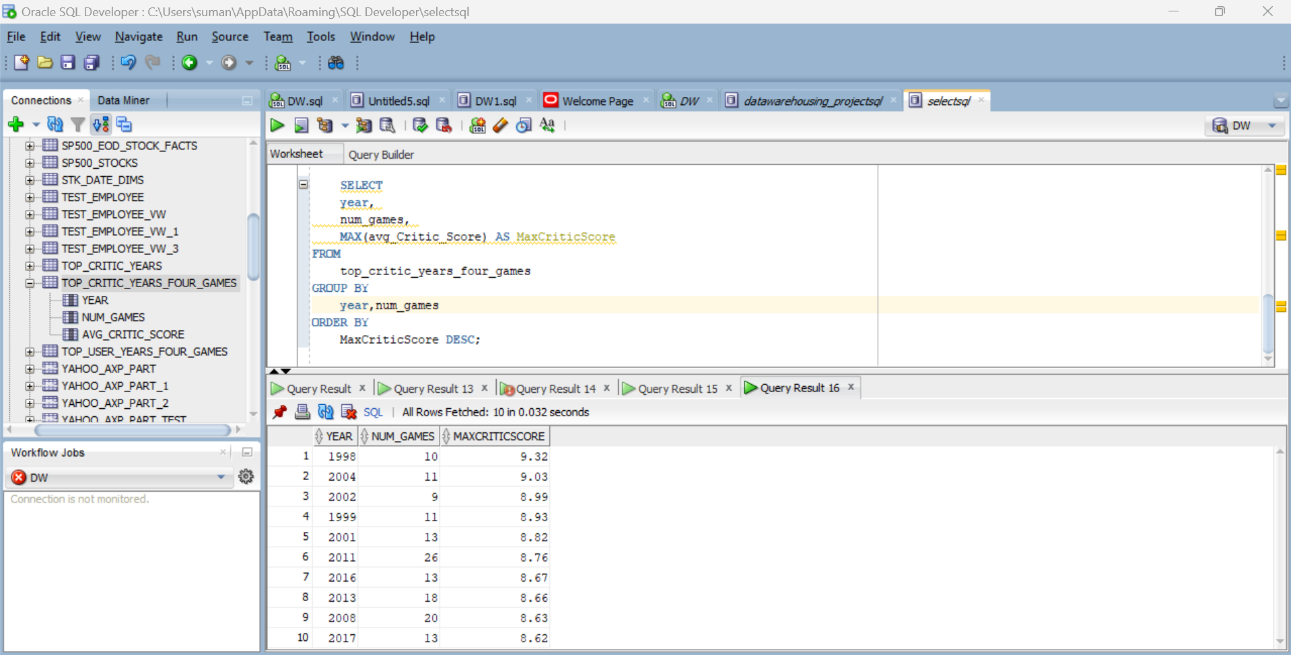

**EDA**

I delved into numerous datasets while doing exploratory data analysis (EDA) on the different tables in our database. The "game_sales" table, which provided excellent insights into the sales performance of video games, was one of the focus areas of our investigation. I discovered trends in game sales across platforms, genres, and time periods using EDA. During the Golden Age of Video titles, we were able to identify top-performing titles and discern market trends in the gaming business.

Simultaneously, the tables "game_reviews," "top_critic_score," "top_critic_scores_more_than_four_games," and "top_user_scores_more_than_four_games" supplied a wealth of information about game reviews and critical response. I studied the distribution of critic and user scores using EDA, discovering relationships between game genres, review ratings, and the frequency of highly scored titles. These findings helped to a thorough understanding of the elements impacting the success and popularity of video games throughout the time period under consideration. Furthermore, the "game_sales_global" table allowed us to examine global game sales, providing a more comprehensive picture of these video game titles' international reach and influence.

The EDA process across these tables has provided us with a deep insight of the Golden Age video game business, revealing trends, patterns, and the interplay between critical reception and economic success. This information serves as the cornerstone for our data-driven insights and decision-making processes, laying a solid foundation for our project's larger ambitions.

**EDA on table - game_sales**

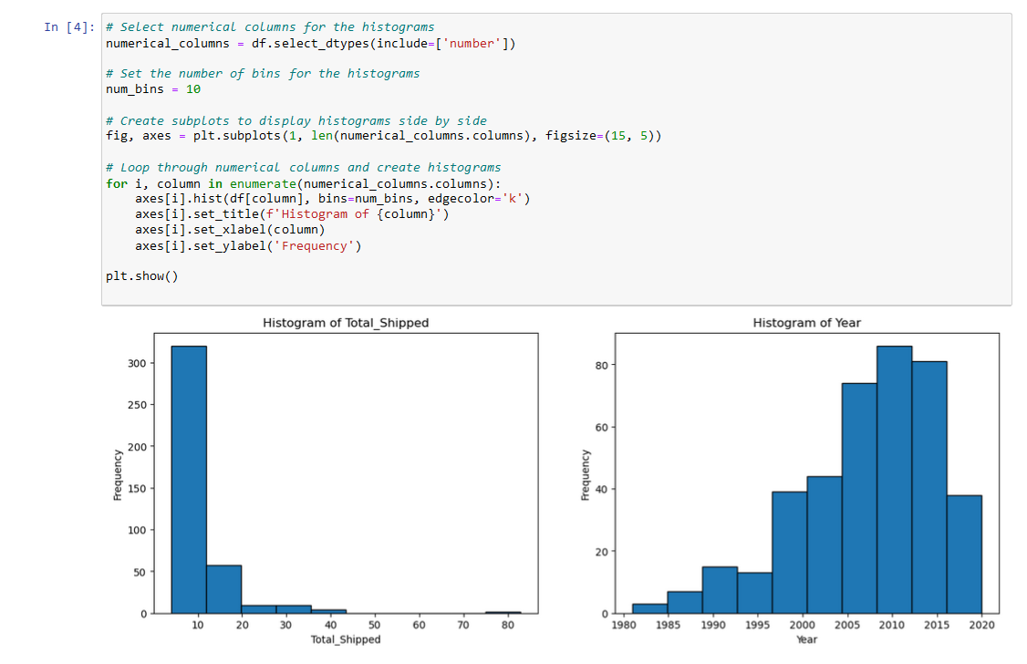

**EDA on table - review**

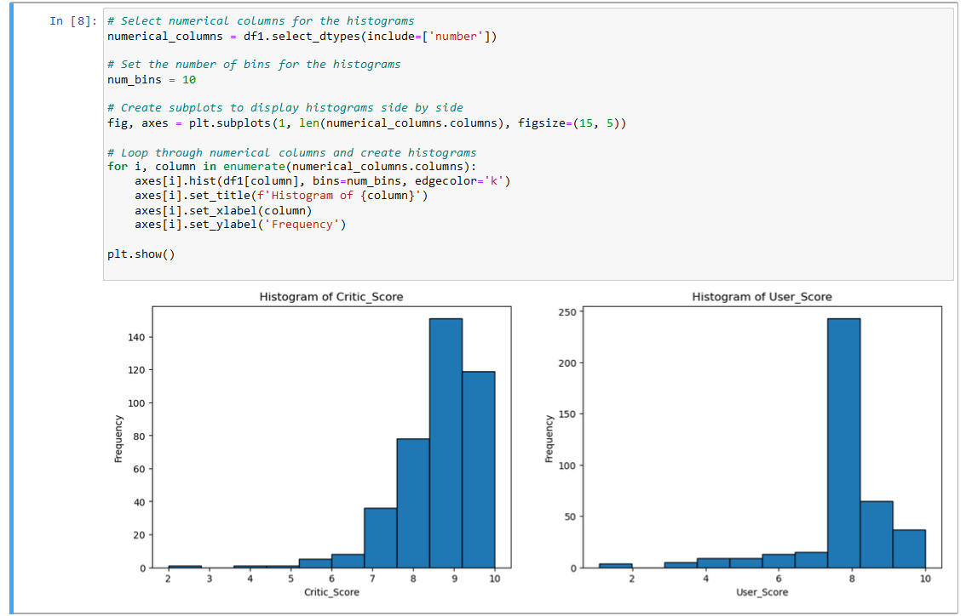

**EDA on table – top_critic_years**

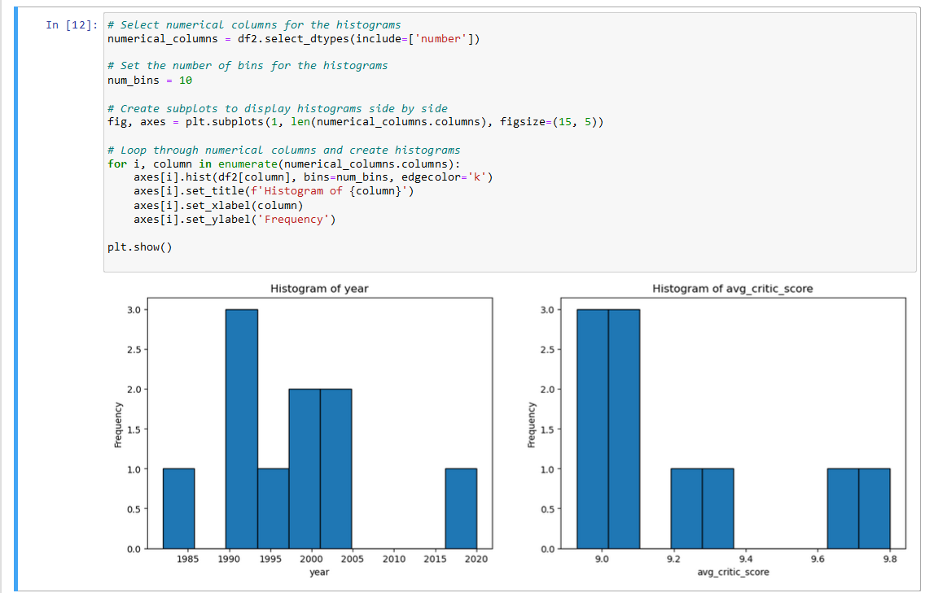

**EDA on table - top_critic_years_four_games**

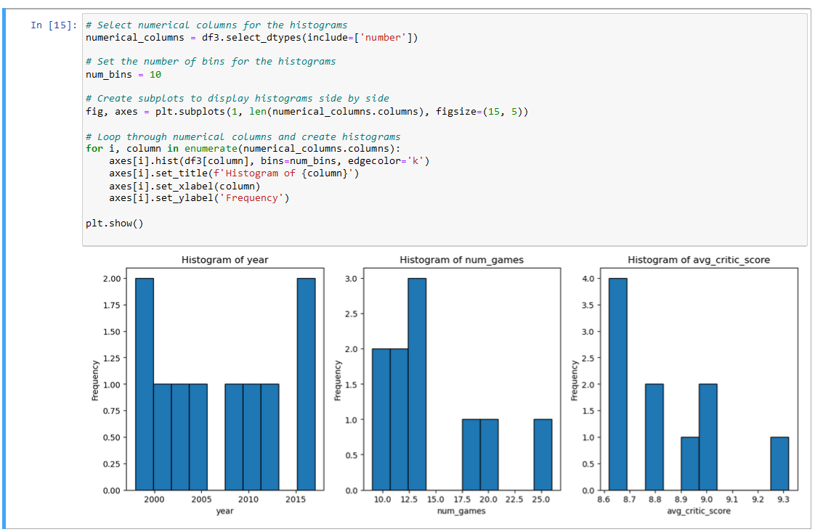

**EDA on table - top_user_years_four_games**

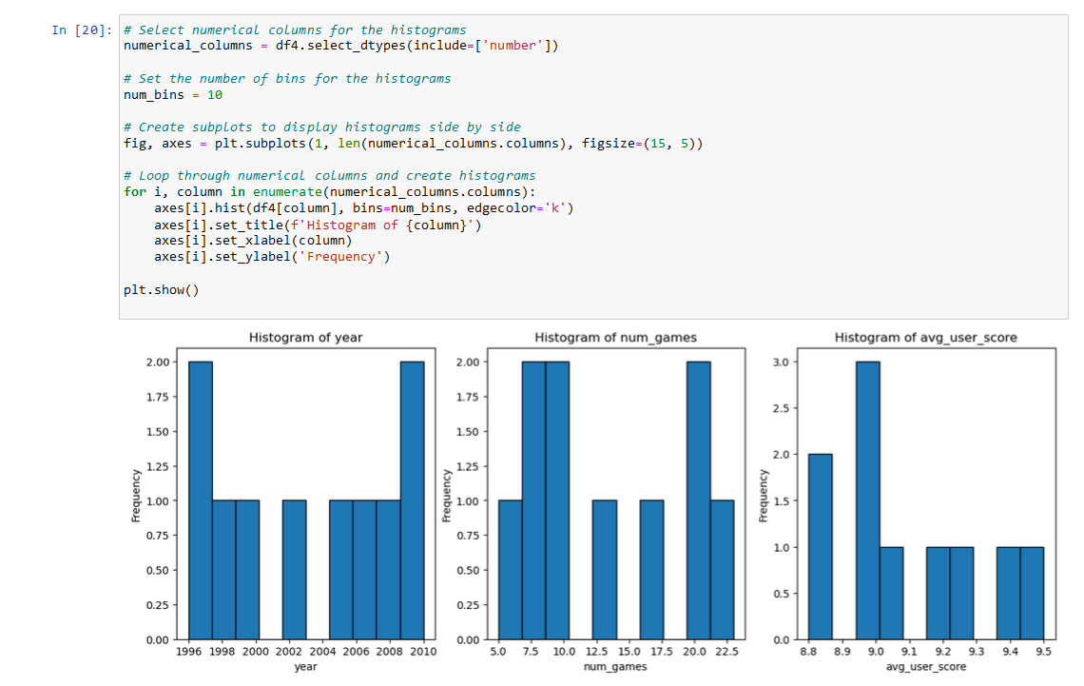

**EDA on table - game_sales_global**

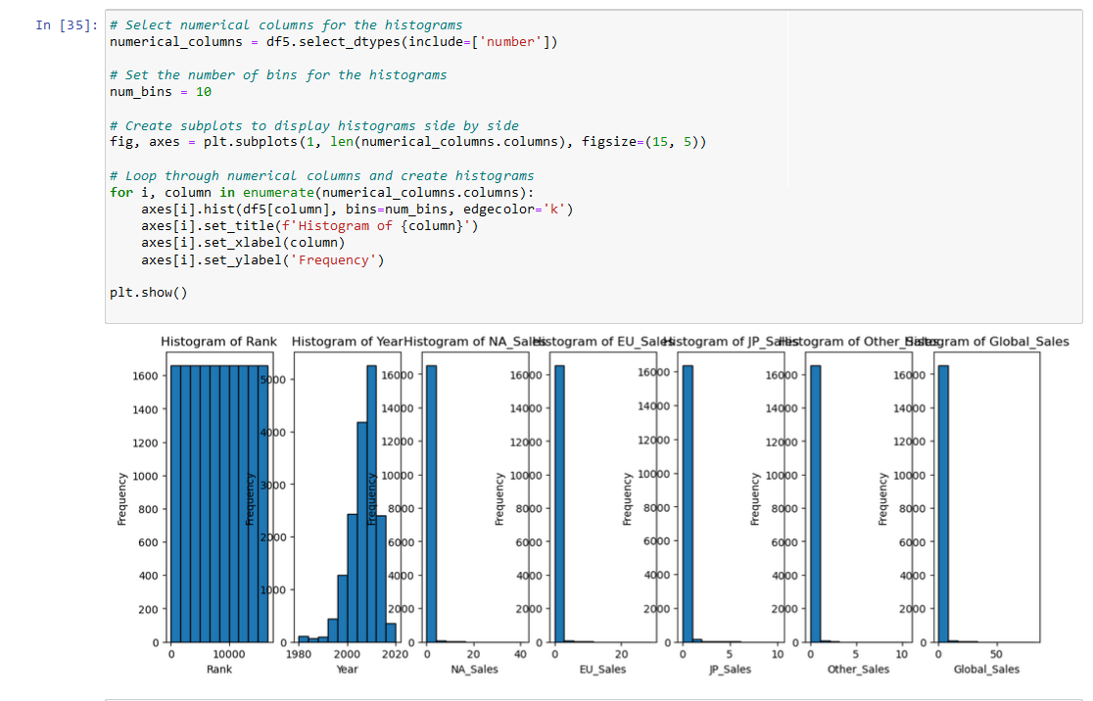

EDA on year VS Platform

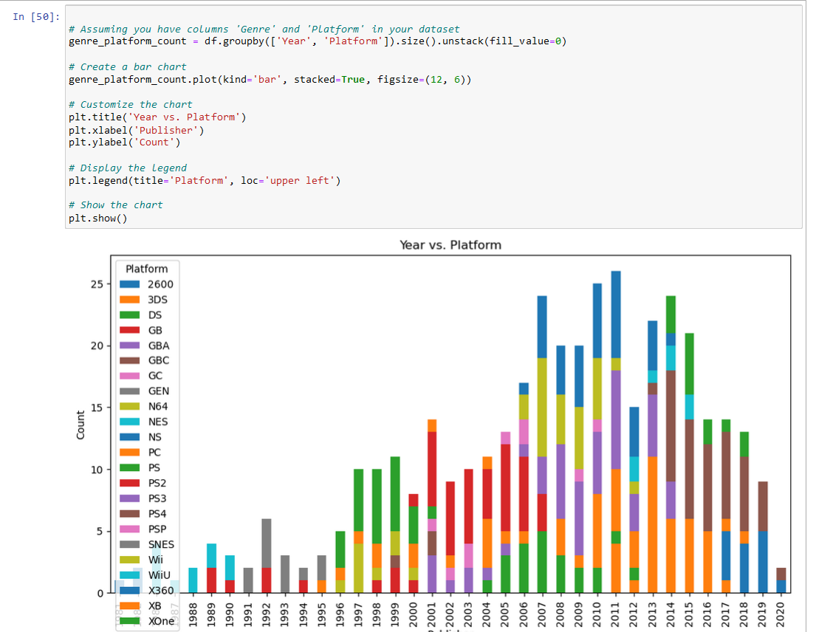

**EDA on Genre and the sales:**

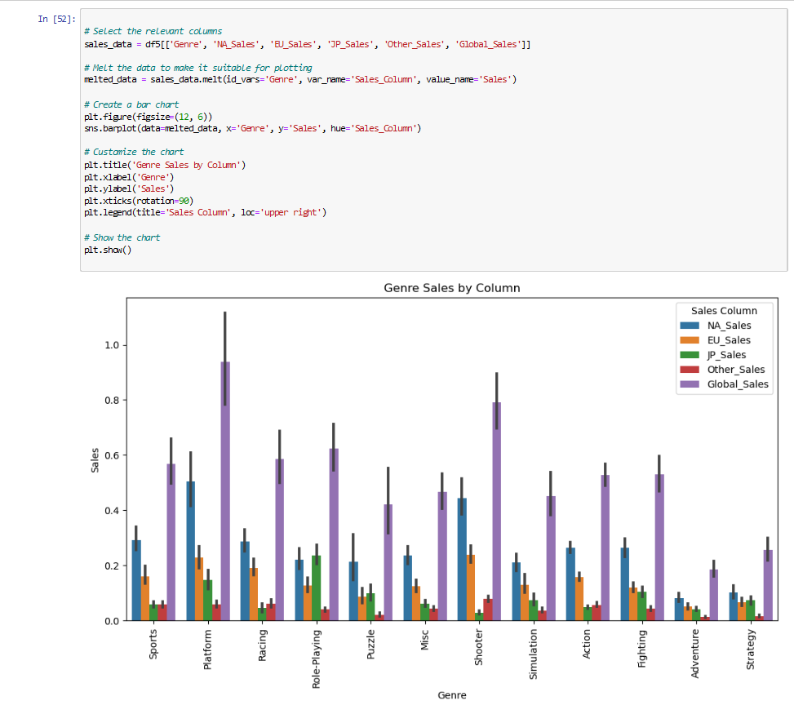

**EDA on Total Count of Games for each Platform**

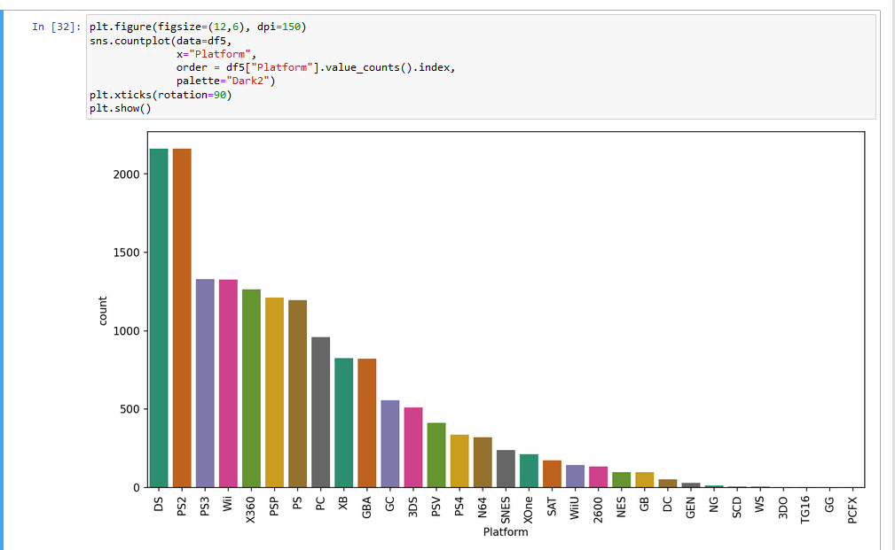

**EDA on Total Count of Games for each Genre**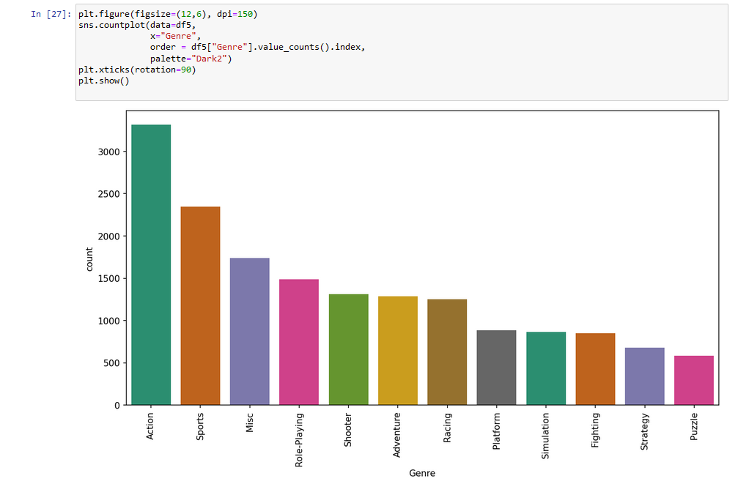

**EDA on Top 5 Publishers By Global Sales:**

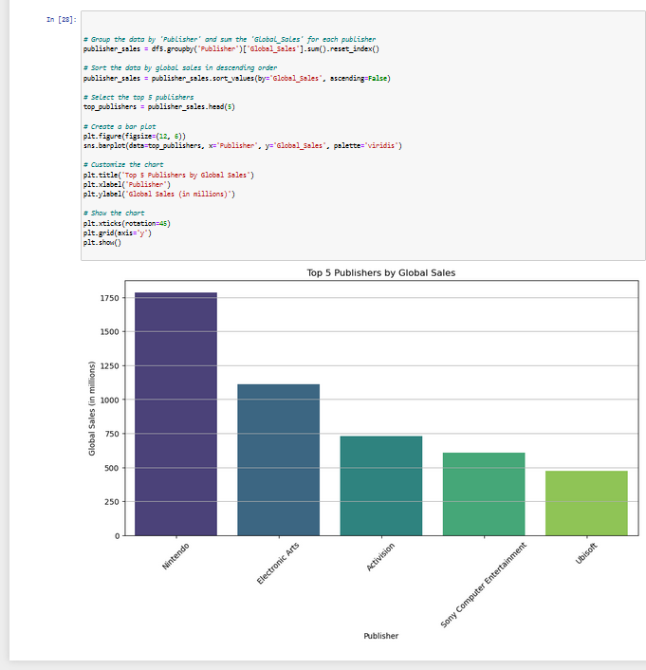

**Visualisation:**

1. The graphical representation showcases a comparison between critic scores and user scores for video game sales spanning the years from 1983 to 2018. The x-axis of the graph denotes the years within this timeframe, while the y-axis quantifies the scores, ranging from 0 to a maximum of 200.

The graph is designed as a line chart, displaying two distinct lines, each signifying the evolution of critic scores and user scores over the years. Notably, the pinnacle of critic acclaim was reached in 2008, whereas user satisfaction hit its zenith in 2013. On the flip side, the nadir of critic evaluation was observed in 1983, while user ratings reached their lowest point in 1993.

Examining the broader trend, it is evident that both critic scores and user scores have demonstrated a consistent upward trajectory over the entire period under consideration. This suggests a general improvement in the quality and reception of video games over the years, with both critical experts and the gaming community expressing growing appreciation for the medium.

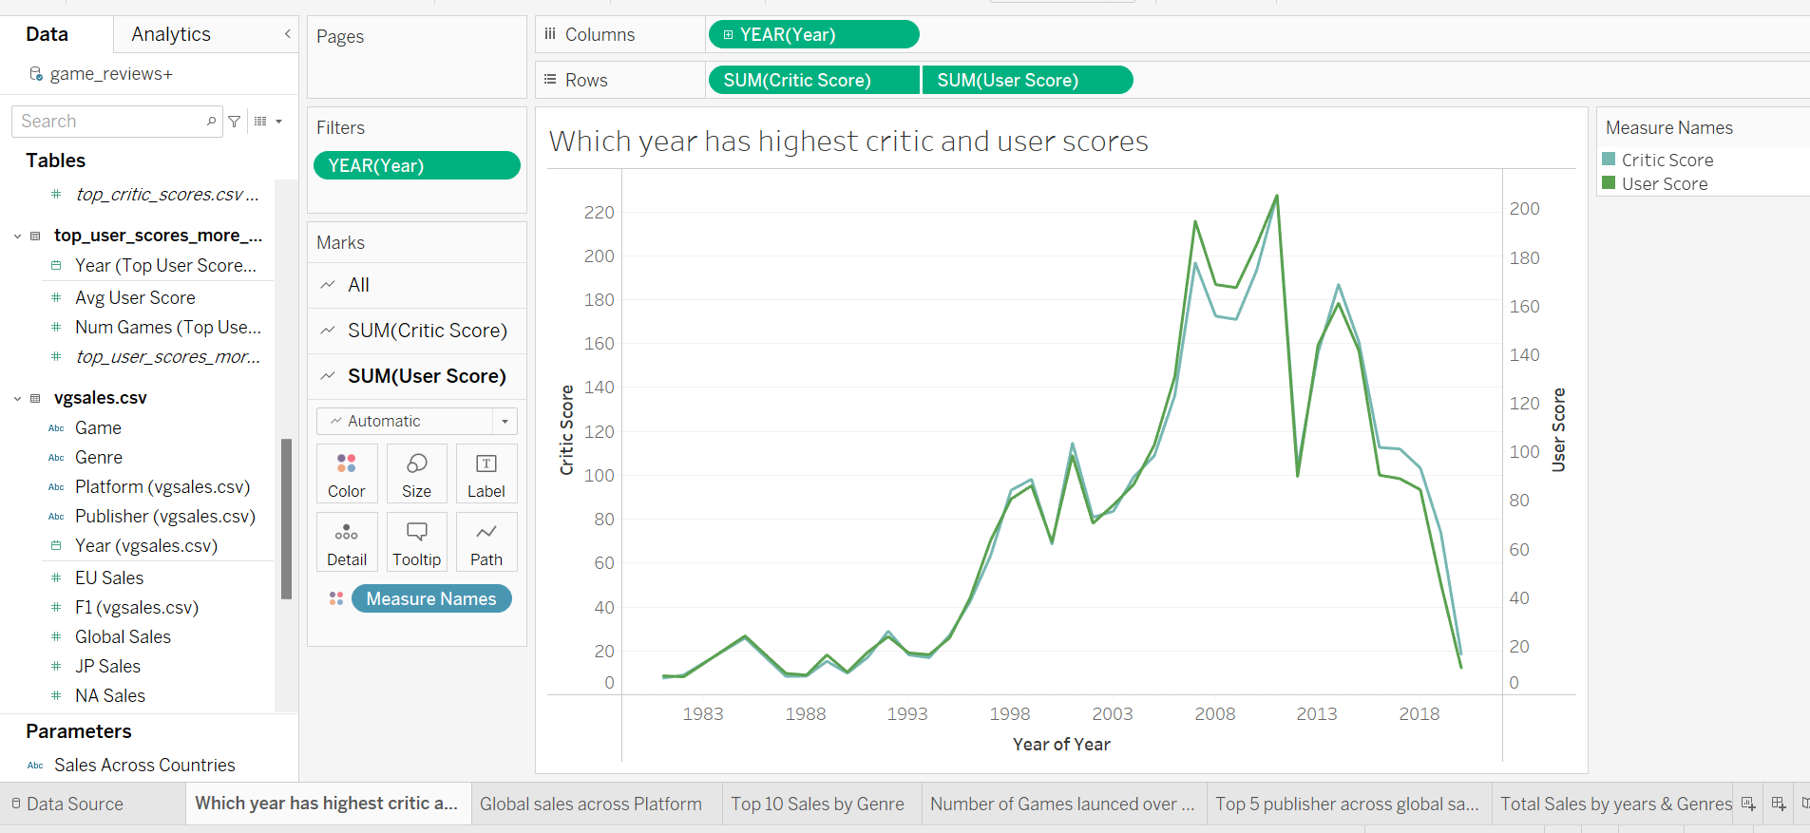

1. The chart illustrates global game sales across various gaming platforms. The platform with the highest sales is the PS4, with a remarkable 1,791.6 million units sold. Following closely behind is the Wii, which achieved 1,236.1 million units in sales, securing the second spot. The X360 platform clinches third place with 1,700.2 million units sold. In contrast, the PS platform lags behind with the lowest sales at 960.3 million units.

In summary, the graph underscores that the PS4, Wii, and X360 platforms reign supreme in terms of global game sales, while the PS platform trails as the platform with the lowest sales. Notably, the PS4 platform stands out with significantly higher sales, possibly due to factors like exclusive game titles, hardware quality, or robust marketing efforts by Sony. Irrespective of the specific reasons, it's evident that the PS4 holds the title of the most popular gaming platform worldwide.

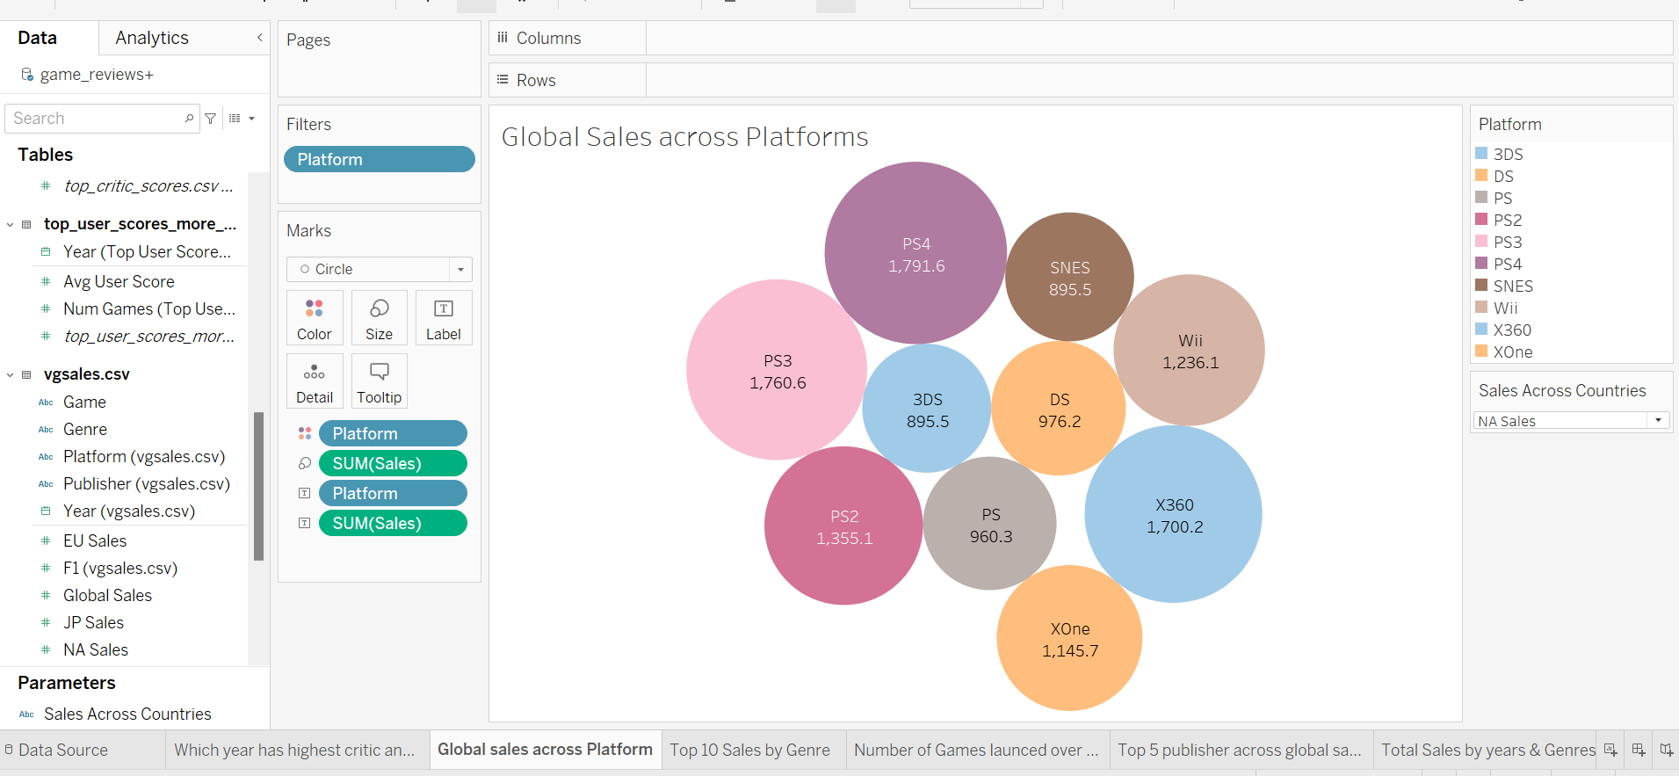

1. The bar chart provides insights into the top 10 game sales by genre. On the horizontal axis, we have the various genres, while the vertical axis measures sales in millions. The genre that boasts the highest sales is the action genre, with a whopping total of over 900 million units sold. Following closely are the sports and shooter genres, with 877.8 million and over 700 million units sold, respectively. In contrast, the strategy genre lags behind, having the lowest global sales with just under 600 million units sold.

In essence, when we examine this chart, it becomes abundantly clear that the action genre dominates the global gaming market with the highest sales. There's a considerable gap between action and the other genres. What drives this phenomenon could be attributed to various factors, including the allure of exclusive game titles, the quality of gaming hardware, or the marketing strategies employed by game developers. Regardless of the underlying reasons, the action genre takes the crown as the most popular gaming genre on a worldwide scale.

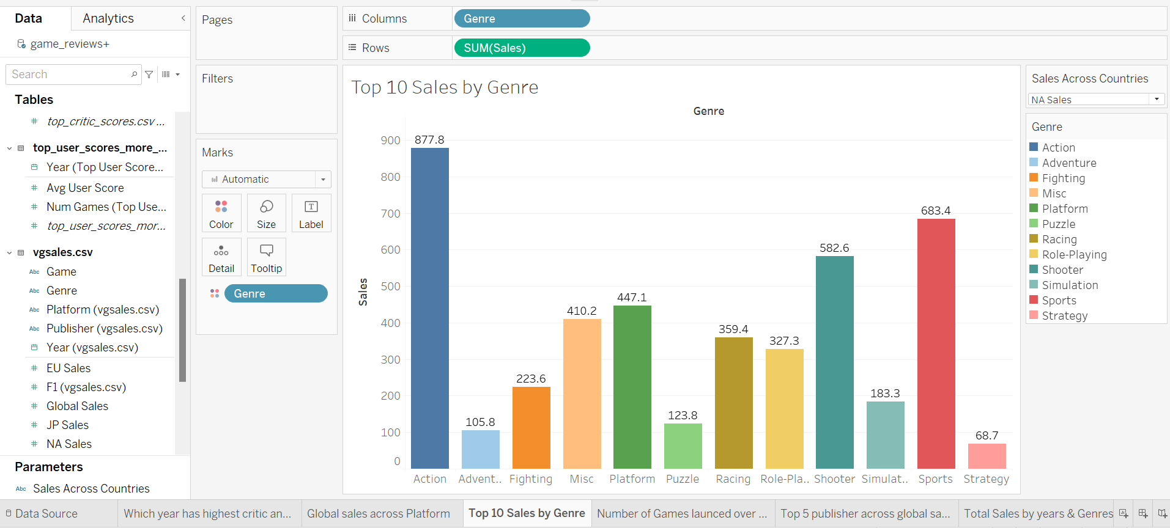

1. The chart takes the form of a bar chart, depicting the quantity of games released throughout different years. On the horizontal axis (x-axis), we find the years, while the vertical axis (y-axis) measures the number of games launched. The peak year for game releases appears to be 2014, boasting a substantial 4,122 games. Conversely, the lowest point in terms of game releases occurred in 1998, with a modest count of 665 games.

Upon closer examination, a clear trend emerges: the quantity of game releases has been on a consistent upward trajectory over the years. However, there are a couple of notable exceptions, with a slight decrease in the number of games launched in 2015 and 2016.

Several factors could account for this temporary decline, such as economic downturns, shifts in consumer preferences, or the burgeoning popularity of mobile gaming. Irrespective of the underlying reasons, the overall pattern underscores the growth and dynamism of the gaming industry.

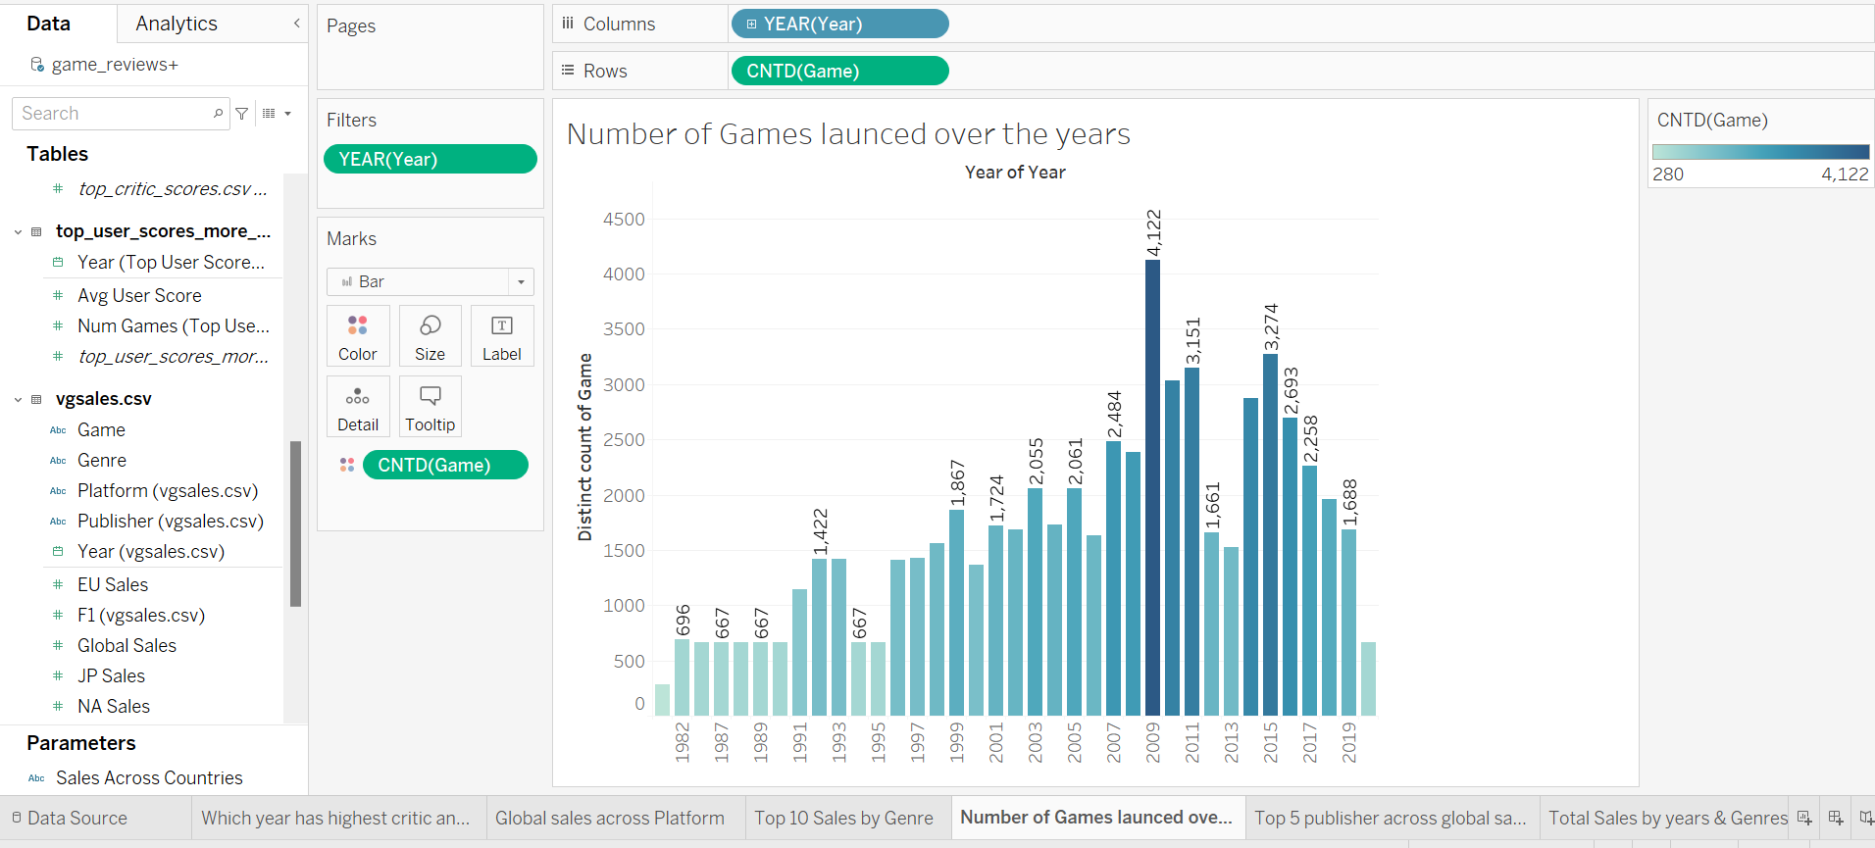

1. The graph displays the leading game publishers in terms of global sales, with Nintendo holding the largest share at 816.9 sales, followed by Electronic Arts at 595.1 sales. Activision and Sony Computer Entertainment come next with 429.7 and 265.2 sales, respectively, while Ubisoft's share is the smallest at 253.4 sales. This indicates that Nintendo is the top publisher globally, followed by Electronic Arts.

According to information from a source, the global games market experienced a decrease in revenue in 2022, with a 4.3% decline compared to the previous year. Notably, mobile game revenues dropped faster than other segments, totaling $92.2 billion in 2022, down by 6.4% year-on-year. Console gaming also saw a decline of 4.2% in spending due to fewer game releases. In contrast, PC gaming showed slight year-on-year growth of 0.5% in 2022. The article also highlights key developments in the gaming industry, featuring insights from market analysts at Newzoo.

Based on this information, it appears that the global games market has been facing a decline in revenue. Despite this trend, Nintendo and Electronic Arts have managed to maintain their positions as the top two publishers in terms of global sales. It's interesting to note that mobile game revenues have been declining faster than other segments, likely influenced by economic challenges affecting people's disposable income. Console gaming has also seen a decline due to fewer game releases, whereas PC gaming has experienced slight year-on-year growth

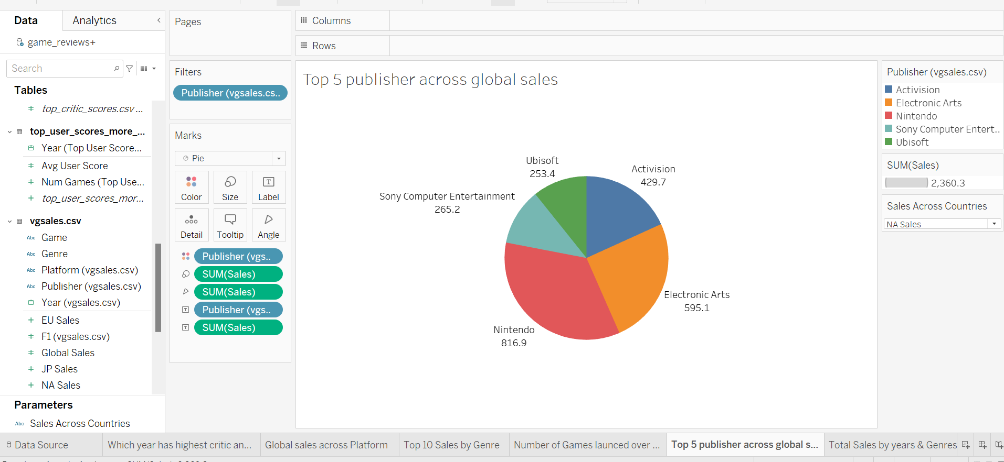

1. The global gaming industry has faced some challenges recently. In 2022, the industry's total revenue decreased by 4.3% compared to the previous year, with mobile games taking a bigger hit, experiencing a 6.4% decline. Console gaming also saw a 4.2% drop due to fewer game releases. On the other hand, PC gaming showed a modest 0.5% increase in 2022. This is all according to a source called Newzoo.

Now, looking at a different angle, we have a graph that shows the total game sales over the years from 1983 to 2018, with different colors representing various game genres. The highest sales were recorded in 2018, totaling around 2800 million units, a significant increase from the lowest point in 1983 when sales were only around 600 million units.

In 2018, the genres that contributed the most to these sales were action, sports, and shooter games. On the other hand, puzzle, strategy, and adventure genres contributed the least to the total sales.

So, while the global gaming market as a whole has experienced some decline in revenue, it's important to remember that the graph reflects the total number of games sold over the years, which has shown an increasing trend. This contrast could be due to various factors such as changes in game pricing, consumer preferences, or different market segments. The decline in mobile and console gaming revenues might be linked to economic factors impacting people's disposable income, while the differences in PC gaming could be related to its unique dynamics.

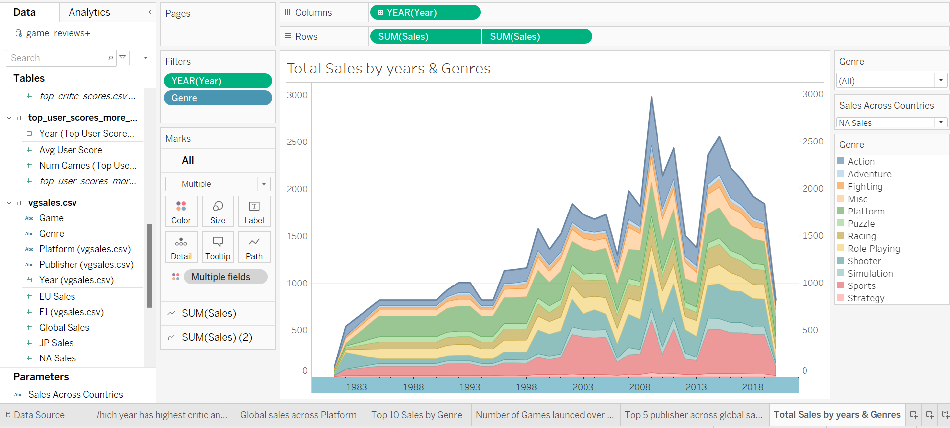

**Dashboard:**

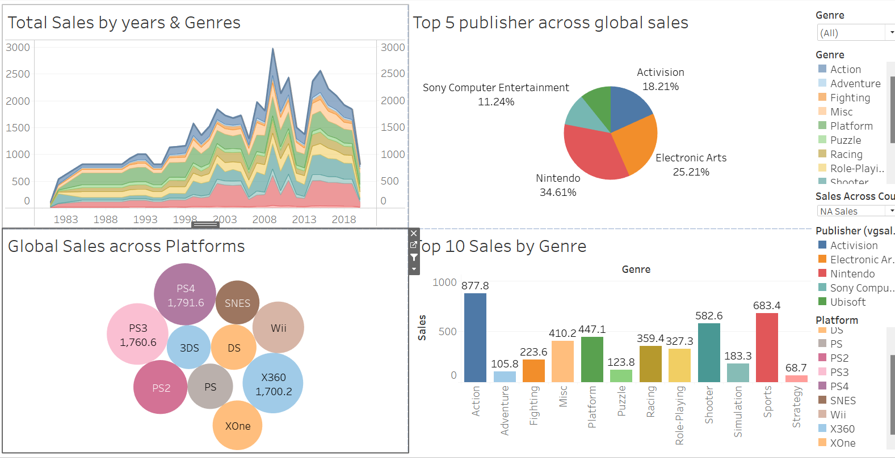

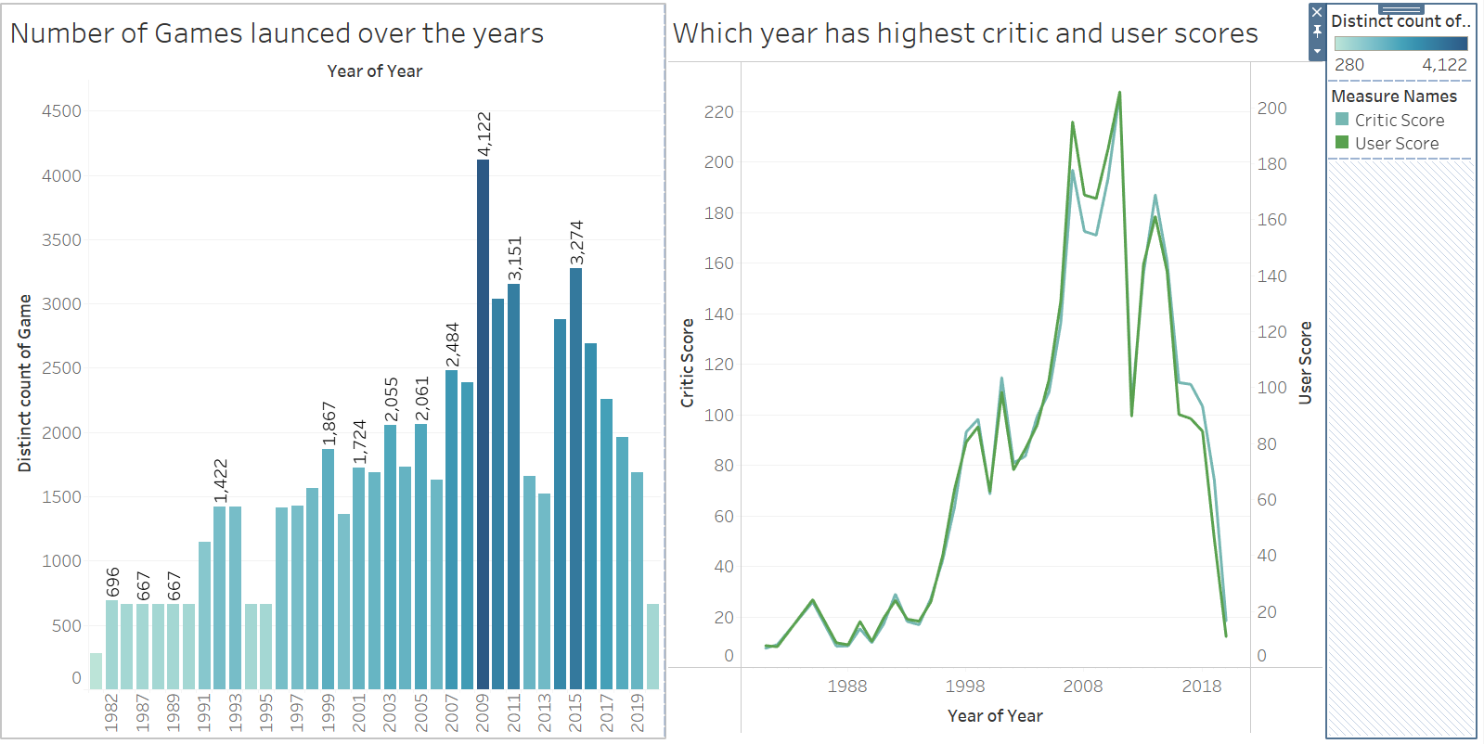

**Conclusion:**

We explored a wide range of variables that intricately affect a game's success in our in-depth examination of video game ranks. Significantly, the complex relationship between a game's title and user opinion emerged, with negative-sounding titles or ones linked to well-liked television shows having a noticeable effect on rankings. This clarifies the psychological impact of branding and the ability of well-known franchises to sway the opinions of customers.

Furthermore, a game's publisher and genre were out to be crucial factors in determining its rating. The necessity of matching game content to changing player tastes is shown by the disparate sales performances across genres, with platform games leading the way. At the same time, the impact that publishers have on rankings highlights how important industry reputation, marketing tactics, and maybe even exclusive relationships are to a game's success. The fact that Nintendo consistently leads the market in terms of sales is evidence of the long-lasting impact of major publishers.

Beyond these variables, our data suggests that the gaming market is dynamic and multifaceted. It implies that a variety of factors, from marketing tactics to genre dynamics, interact to determine success, rather than being determined by just one or two variables. As the gaming business develops further, publishers and developers that want to stay ahead of the curve and earn a top spot in the rankings will need to be flexible and have a deep awareness of these many components. In the end, our research highlights the complex interplay among customer preferences, market strategy, and inventiveness that determines how successful video games are in the cutthroat entertainment industry.

**Visualisation1 - Query**

